YOUR LOGO

How to Submit Tickets
and Service Requests
[MSP Name] IT Portal

SUMMARY
In this guide, we’ll show you how to submit both a support ticket and a service request through the [MSP Name] IT portal.

[MSP Name]
[Company Website Link]
[Support Address] – [Support Phone Number]

Why Should You Use the Portal?
When you submit a ticket or service request through the portal, your request goes directly into our internal resolution queue that’s tracked by our entire team. With the portal:
- You can track your own tickets, so you always know what the status of things are
- You get the fastest possible resolution times with priority queuing.
- You reduce and eliminate back-and-forth emails asking for additional information.
If you require assistance during any point of process, don’t hesitate to reach out to support by emailing ACCOUNT MANAGER EMAIL or calling ACCOUNT MANAGER PHONE.

Log in to the Portal
Start by logging into the portal. Once you’re logged in, the system will automatically open a tie tickets you open to your name, so we can get back to you as soon as possible.
To log in, visit INSERT LINK TO CLIENT PORTAL URL and enter your credentials that your account manager discussed with you.
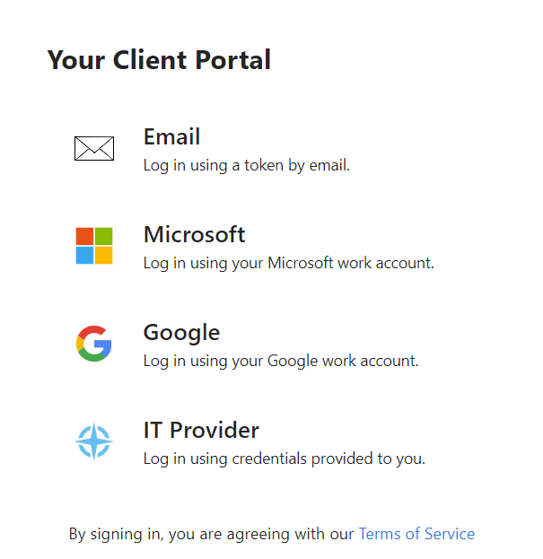

Find the Problem Report/Service Request Menu
Depending on your home screen view, you can find the support requests in two different areas.
If your account manager has set your home page to support, you’ll see icons like this:

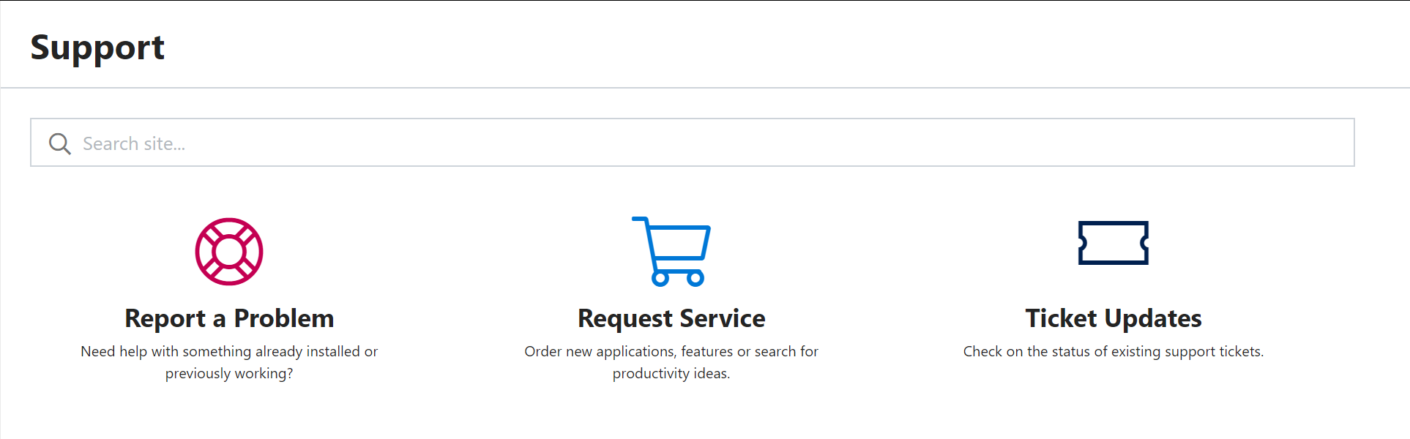
If you have another home page, you can find the same options on the left-hand menu, like this:

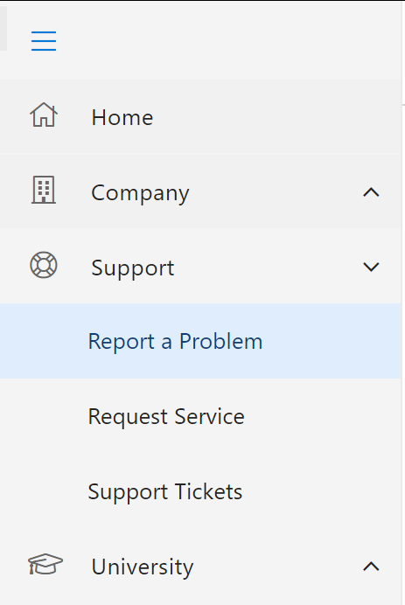

You’ll need to either submit a problem report ticket or a service request ticket based on need.
Problem reports are for errors and IT problems.
Service Requests are for things like ordering new equipment, onboarding new users, setting up accounts, and more – things that IT can help with, but aren’t specifically problems.

3. Submit your Ticket or Service Request
Click either “Report a Problem” or “Request Service” to see your available options.
Click on the category and individual item within that category that best suits your needs and fill out the fields as required. Once you’re all set, click submit.

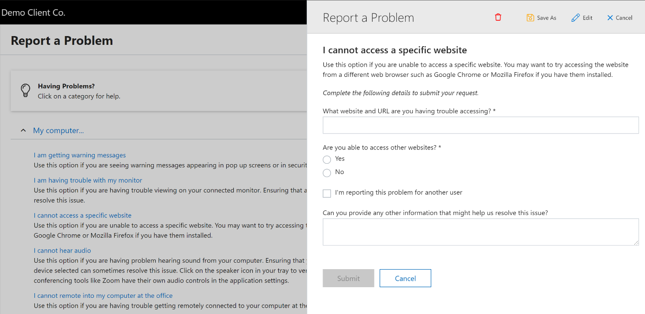
Submitting a Problem Report
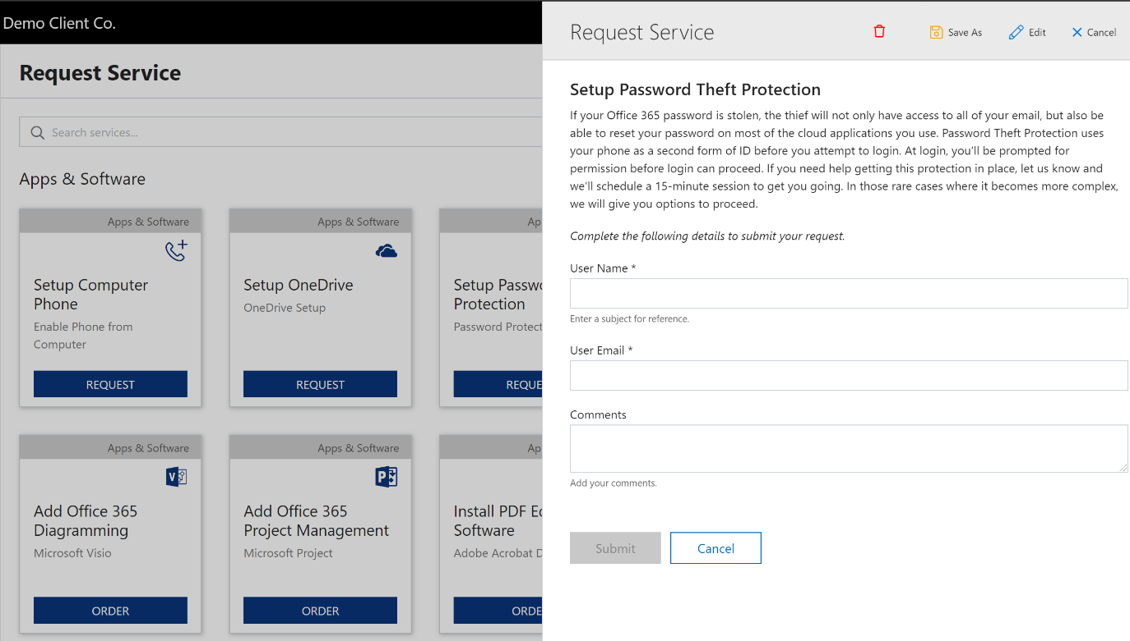
Submitting a Service Request

4. Tracking and Updating Your Tickets and Requests
Once you’ve submitted your ticket and/or service request, you can track the status using the “Ticket Updates” button on the home page, or the “Support Tickets” option in the menu, as seen in step 2.
Users within the portal will be able to see and track their own tickets only.
Company admins will be able to see tickets input for the entire company.
You can also review tickets that are Open, Closed, and Waiting via the tabs at the top of this view.
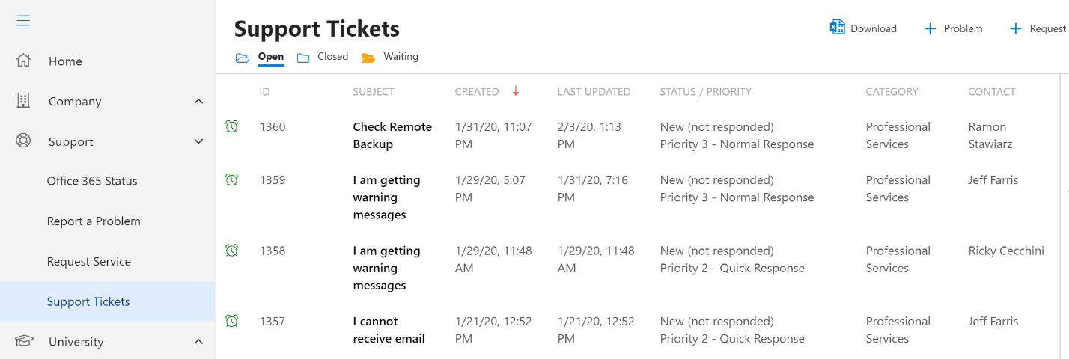
A view of all open tickets.

Clicking on an individual ticket will show you additional options, like the ability to give feedback, add new files, send more information, and even close the ticket yourself if it gets resolved.
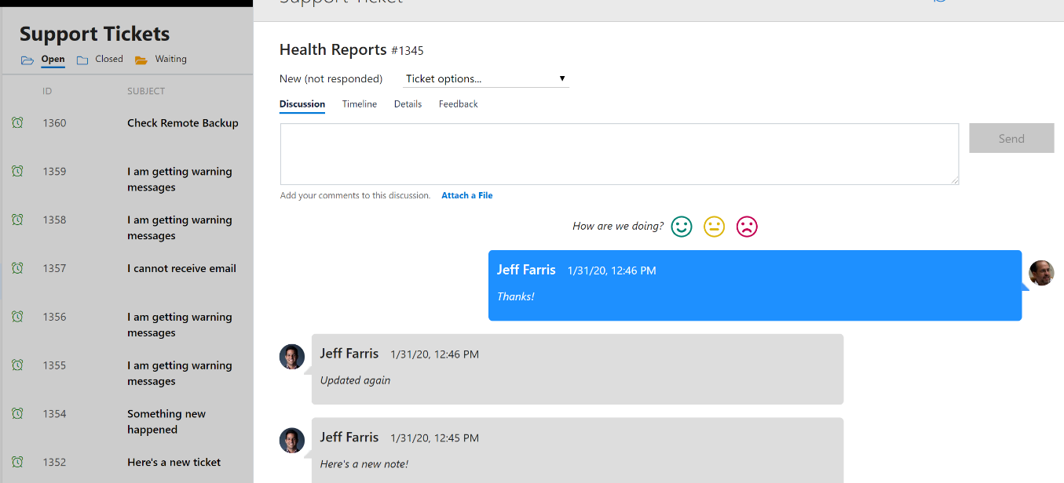
A view within an individual ticket.

