YOUR LOGO

Understanding Approvals
and General Ticket Actions
[MSP Name] IT Portal

SUMMARY
In this document, we will show you the workflow of tickets requiring actions and approval through the [MSP Name] IT portal.

[MSP Name]
[Company Website Link]
[Support Address] – [Support Phone Number]

How do ticket actions work in the portal?
Certain tickets, especially for equipment purchases and HR matters, may need to go through an internal approval process before they reach the IT support team for completion. Sometimes, the action may be simpler – such as to escalate the ticket to another team. There’s also the more day-to-day actions like cancelling, closing, and re-opening tickets.
If you are an administrator approver, knowing this process helps you understand exactly what to expect.

General Ticket Actions
In most cases, you have the option of taking an action with your tickets (both open and closed). If you select an open ticket from the Support > Support Tickets area, you’ll have the option of using a drop-down menu to select your action.
Most commonly, these actions are:
- Close a ticket
- Cancel a ticket
- Re-Open a ticket
However, depending on your role and company settings, you may see more or less than what’s described above.
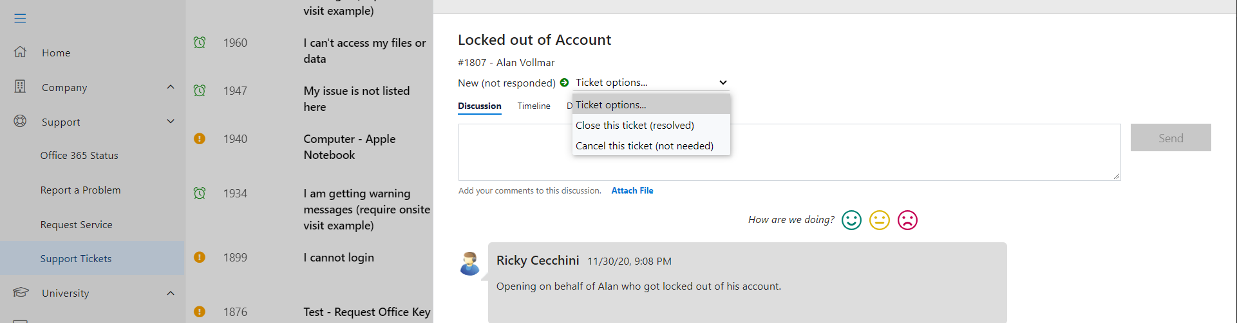

Understanding Approval Workflows

Some tickets may require more intricate actions, such as those requiring approvals.
There are 3 total steps to tickets requiring an approval. They are:
- The ticket submission by a user
- The admin notification
- The approval or denial

The Ticket Submission by a User
When a user submits a ticket that requires an approval, they will be able to track and see the status via the Support Tickets area of the sidebar. The user (and those with global ticket viewing rights) will see this displayed like the image below, both in the Open tab (which shows all open tickets, including those needing approval) and the Waiting tab (which shows only those needing approval).
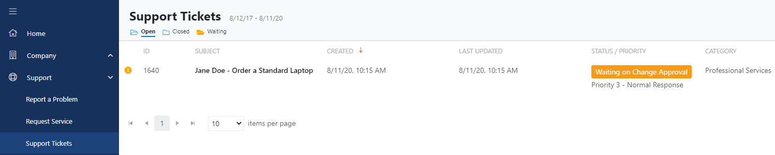

The Approver Notification
With the portal, we can select specific tickets that require approval – as well as their respective approver(s). If you are one of the individuals that is elected to approve tickets, you will be notified in two distinct ways – both via email and in the portal.

The email that you will receive in your inbox:
YOUR LOGO
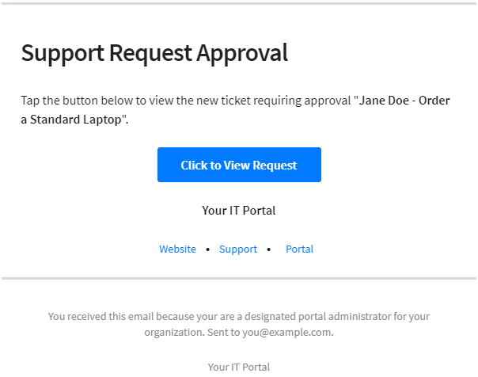
The portal message that you will receive on the homepage:

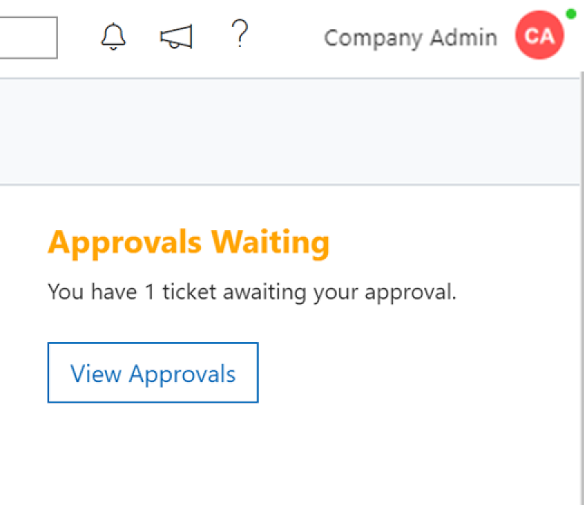

Approving or Denying a Ticket
Once the approver is ready to approve or deny the ticket, the link in the email or the button in the portal will take them to the Support Tickets area. Tickets requiring internal approval will be marked with a status containing an orange tag.
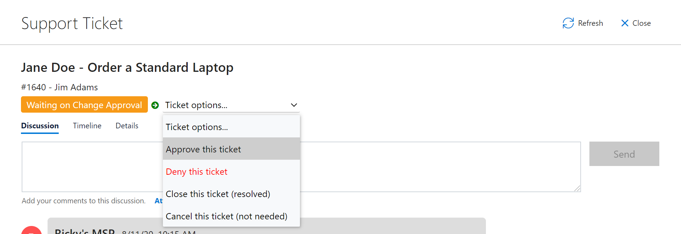

Two things can happen to the ticket at this stage.
- If the ticket is approved, it will be sent to our team for fulfillment.
- If the ticket is denied, the ticket will move to a different status and close/resolve itself.

There may be other actions in your portal (such as escalation processes), but the general flow will be similar to what’s listed here.

